**Project Title- AI-powered Nutrition Analyzer for Fitness Enthusiasts Project Design Phase-I - Solution Fit Template Team ID: PNT2022TMID27756**

**Focus on J&P, tap into BE, understand RC**

**Explore AS, differentiate**

**Deﬁne CS, ﬁt into CC**

**\*What are the variable and fixed business costs associated with operating the business successfully?**

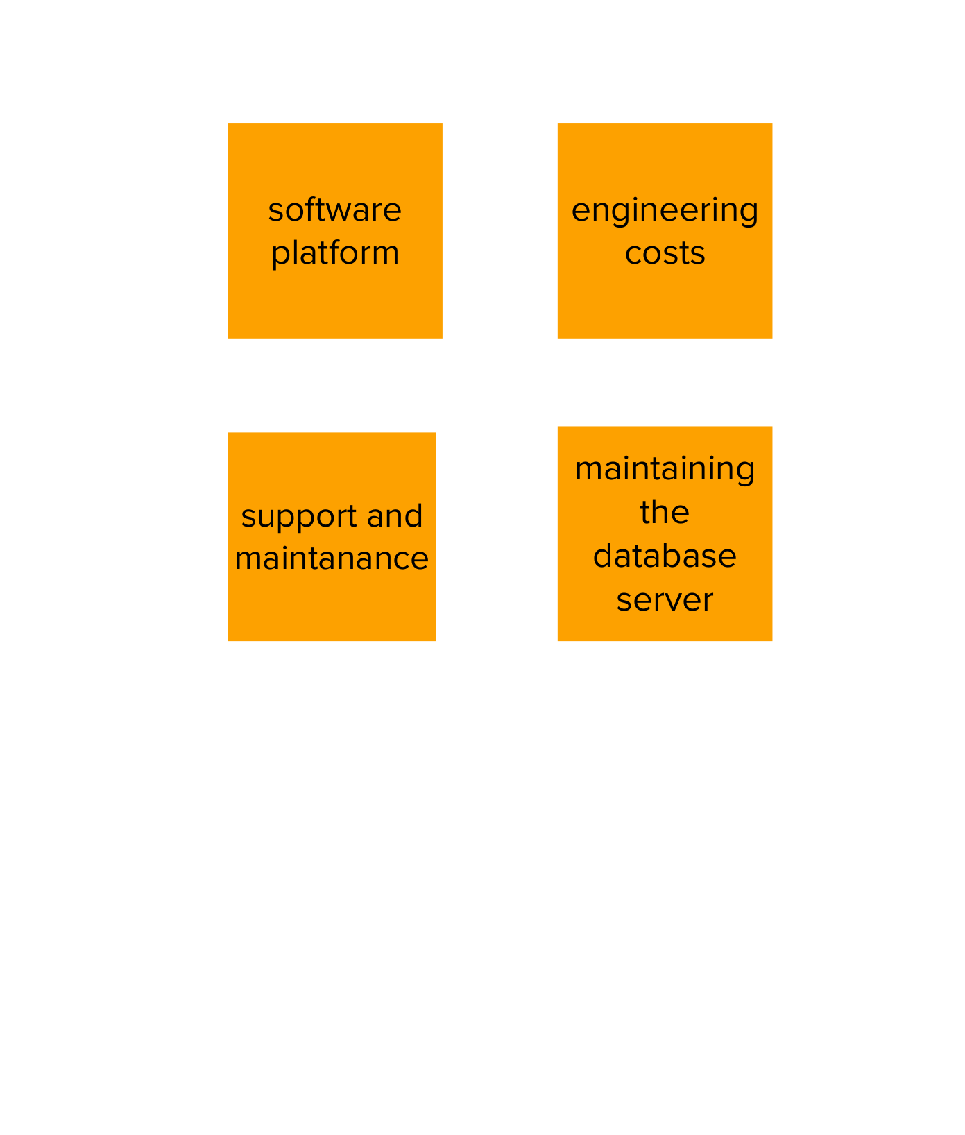

**AS**

**8. COST STRUCTURE**

**\*What key alliances and partnerships are important for the business to succeed?**

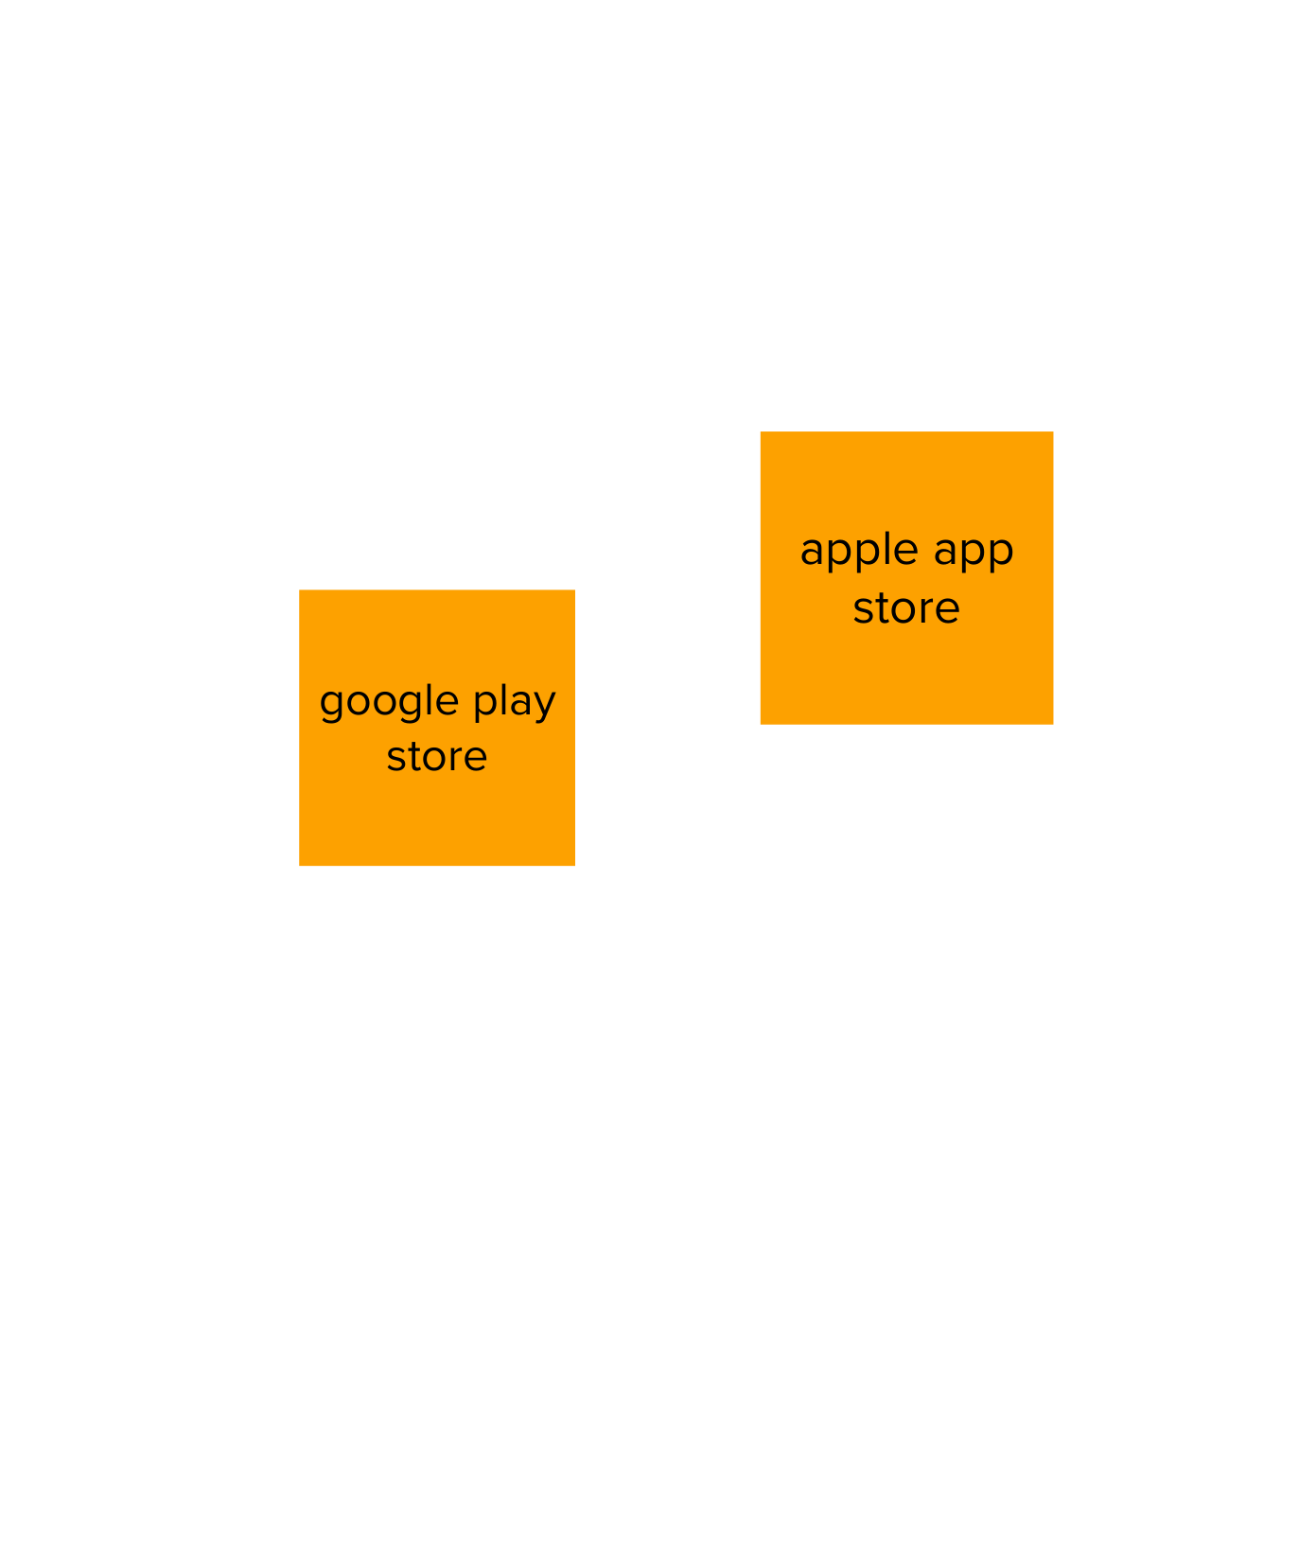

**CC**

**5.** **KEY PARTNERS**

**CS**

**1. CUSTOMER SEGMENTS**

**\*Who is your customer**?

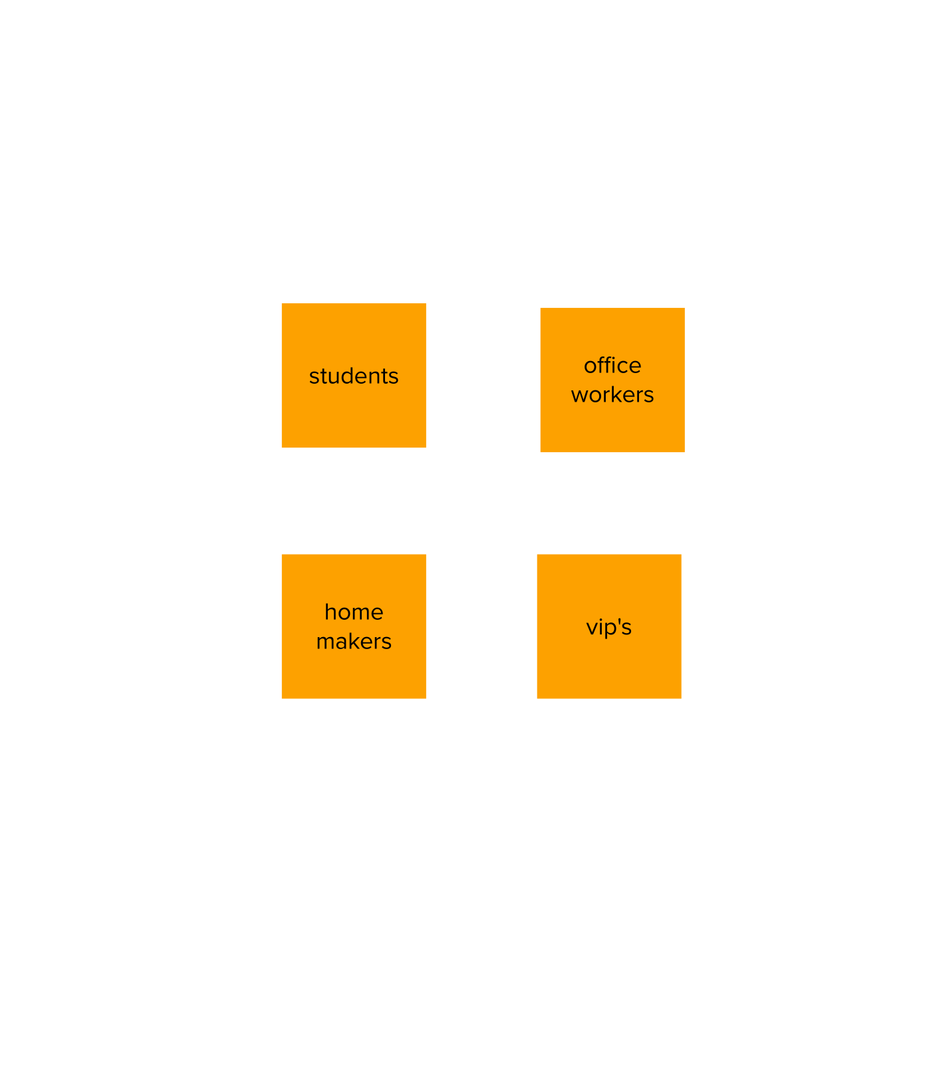

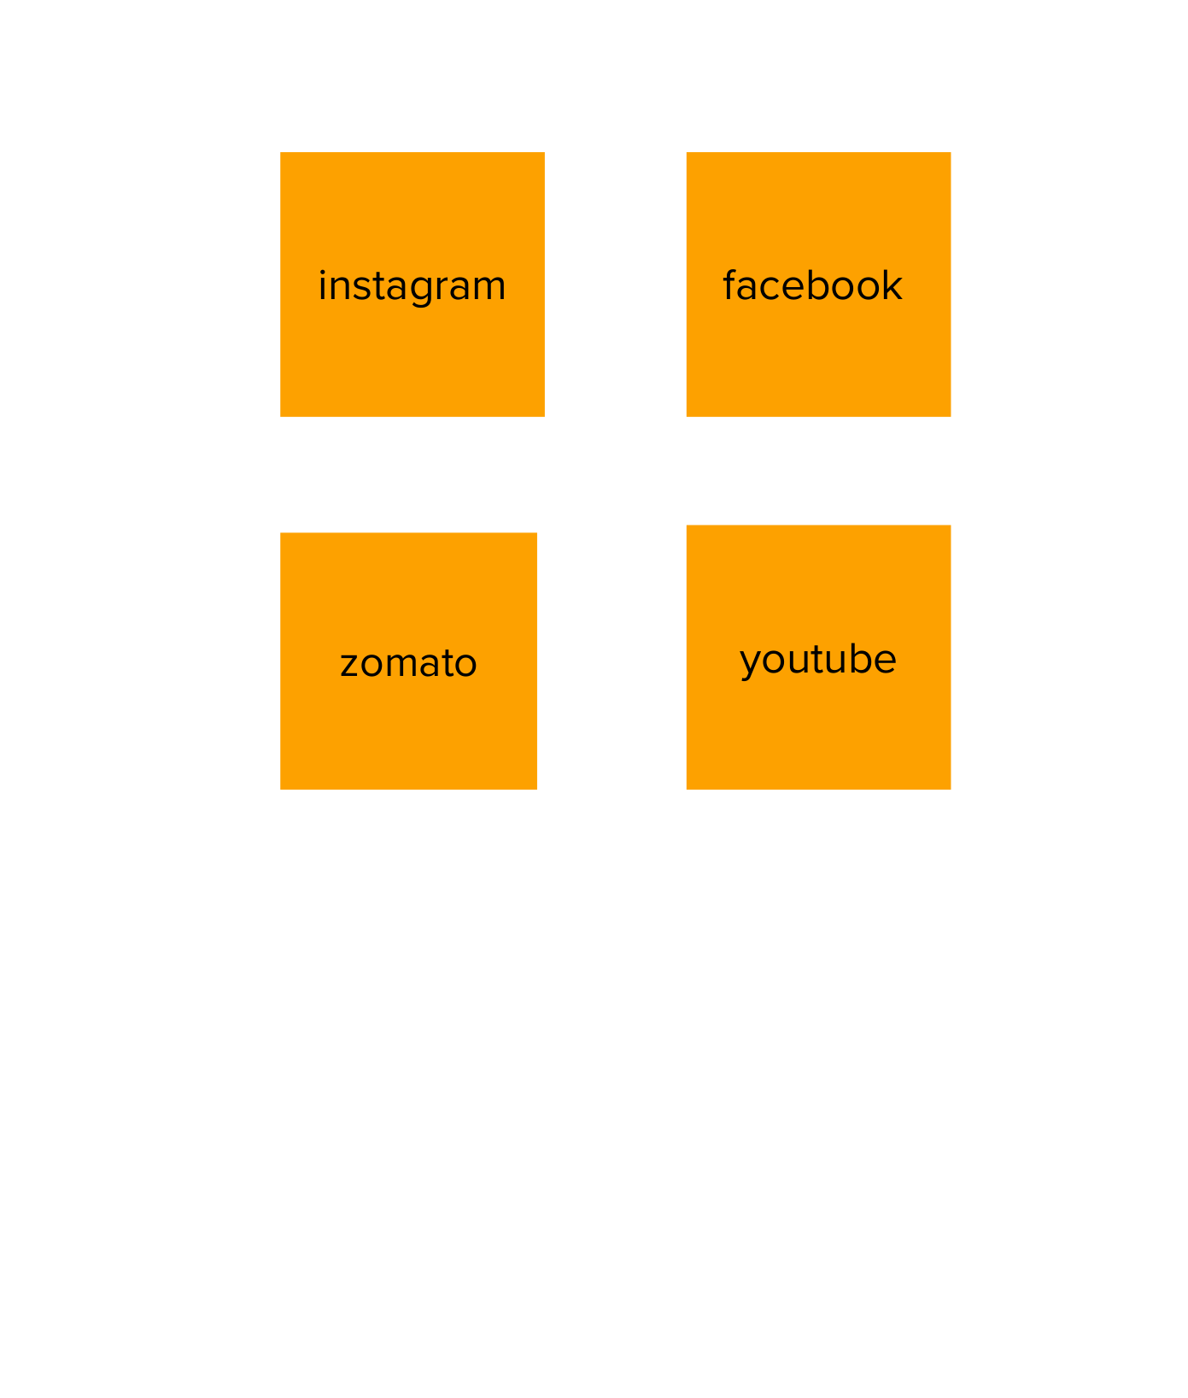

**BE**

**9. CHANNELS**

**\* How will customers learn about our business and interact with our business? How will they receive our product?**

**RC**

**6. KEY RESOURCES**

. **What assets, materials, supplies, etc., must you acquire for your business to succeed?**

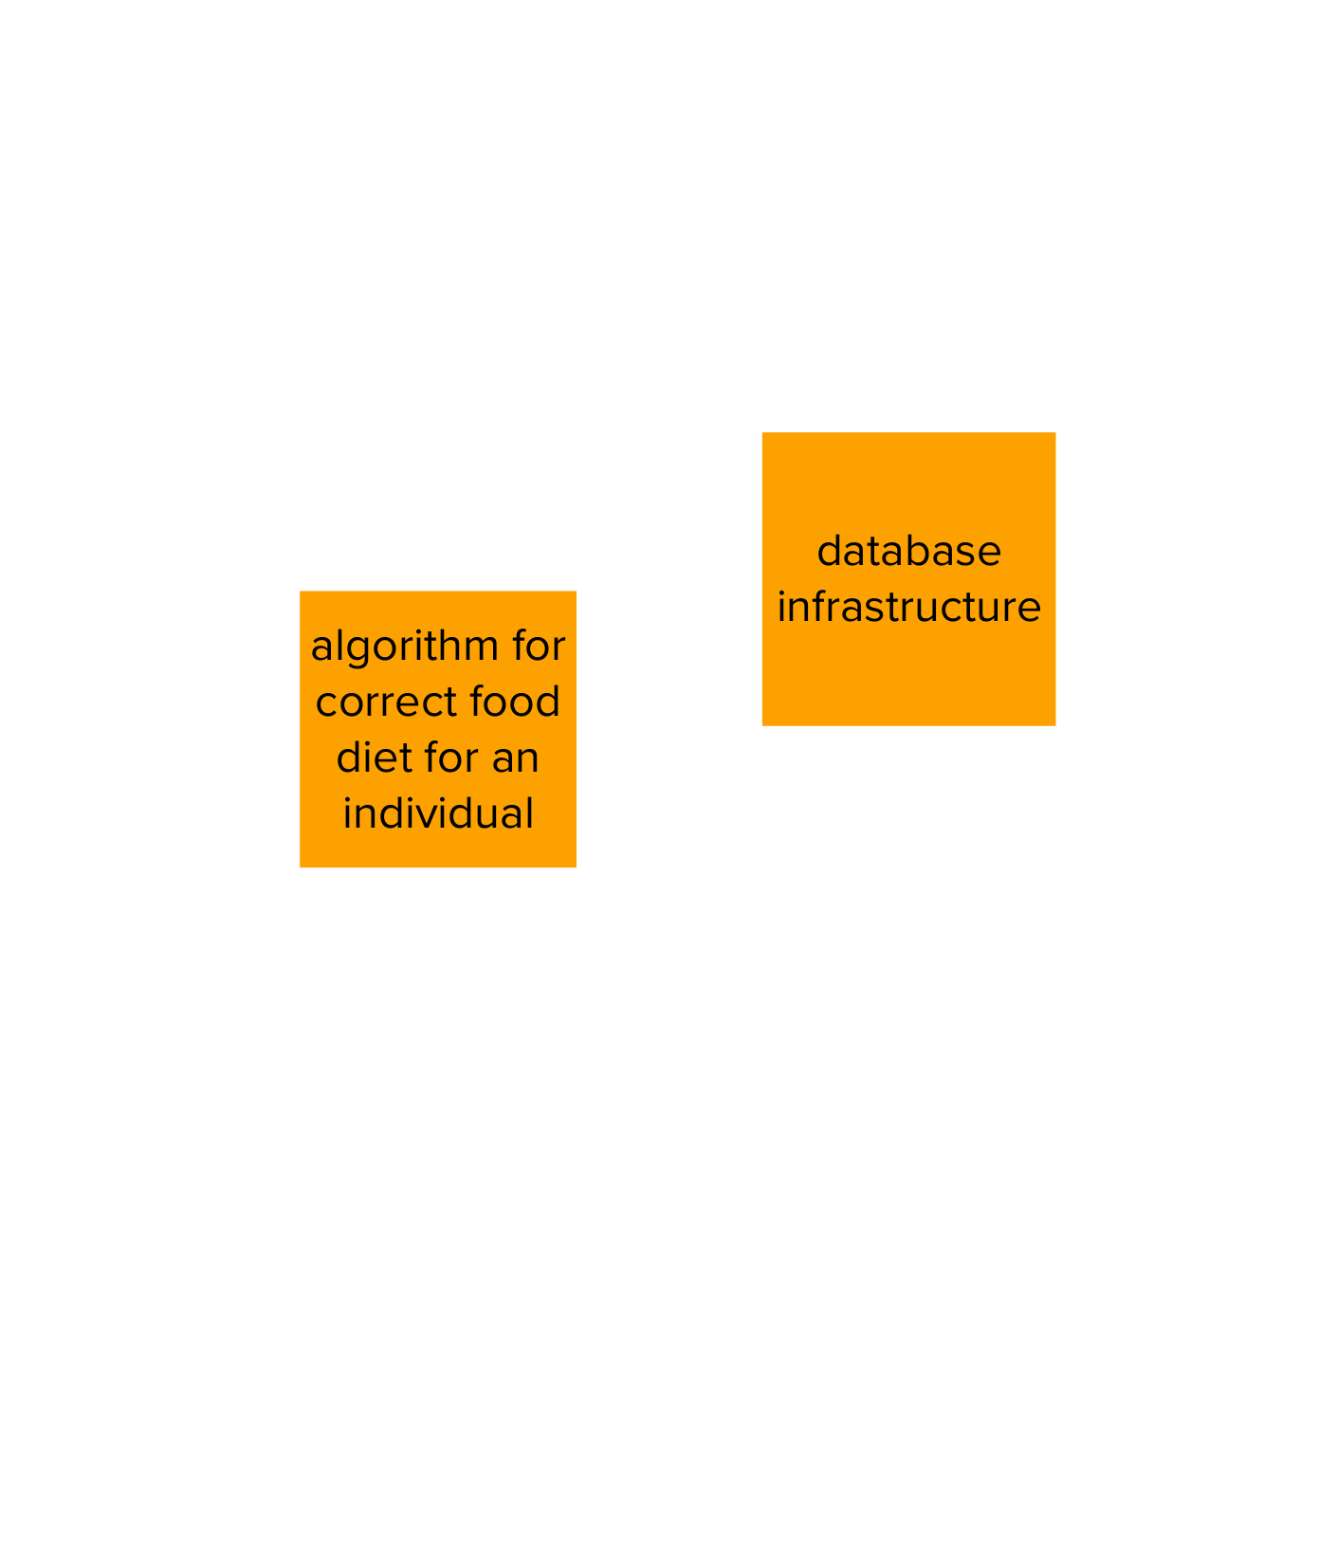

**J&P**

**2. VALUE PROPOSITIONS**

**\* What value do we plan to deliver if they buy?**

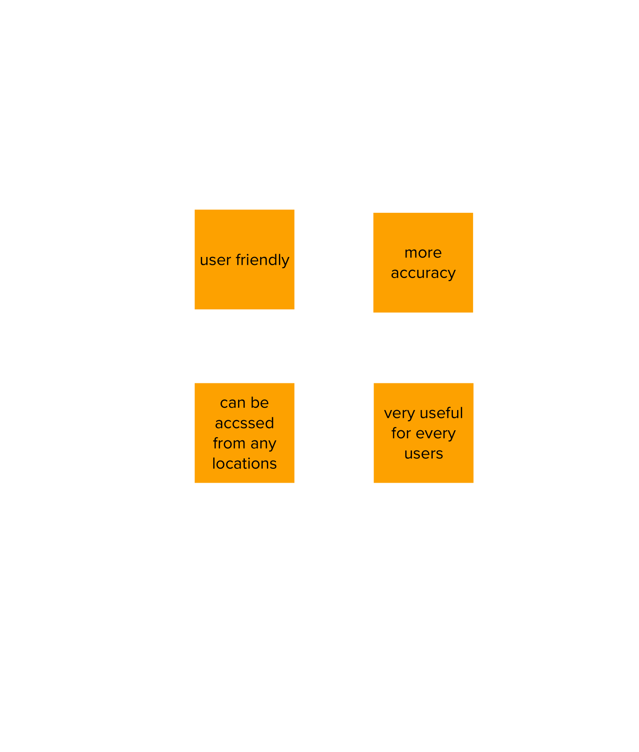

|  |  |  |  |  |
| --- | --- | --- | --- | --- |
| **Identify strong TR & EM** | **3. CUSTOMER RELATIONSHIPS**  **\* List out all important customer relationships that are key to the business.** | **7. REVENUE STREAMS SL**    **\*Where will revenue come from? What sources** |  |  |
| **4.** **KEY ACTIVITIES**  **\*What are the most critical activities your company must do for your business to succeed?** |